**QUIZ 4:**

* 1. 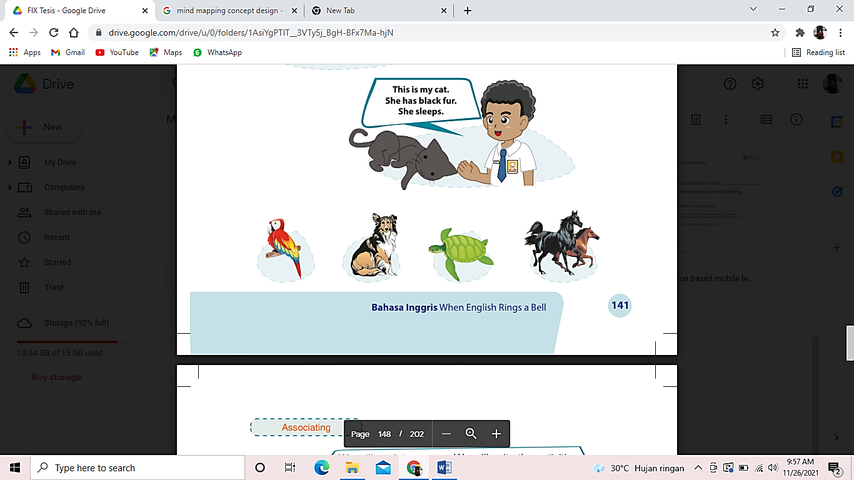

**_ _ _ _ _ _ (PARROT)**

* 1. 

**_ _ _ _ _ _ (TURTLE)**

* 1. 

**_ _ _ _ _ (HORSE)**

* 1. There are some birds. They have colorful feather. They sing beautifully. They …. and perch on a tree.

a. Bite

b. Fly

c. Roar

d. Swim

* 1. That is a …. . It has sharp claws and teeth. It roars and attacks its preys. It eats meat it belongs to carnivore animals.

a. Dog

b. Fly

c. Sheep

d. Tiger

Note:

1. Yang dimerahi adalah jawaban yang benar
2. Total poin 100 (1 soal=20 poin)
3. Untuk bagian yang no 1-3. Siswa dapat menyusun kata dengan beberapa huruf acak yang sudah di sediakan.